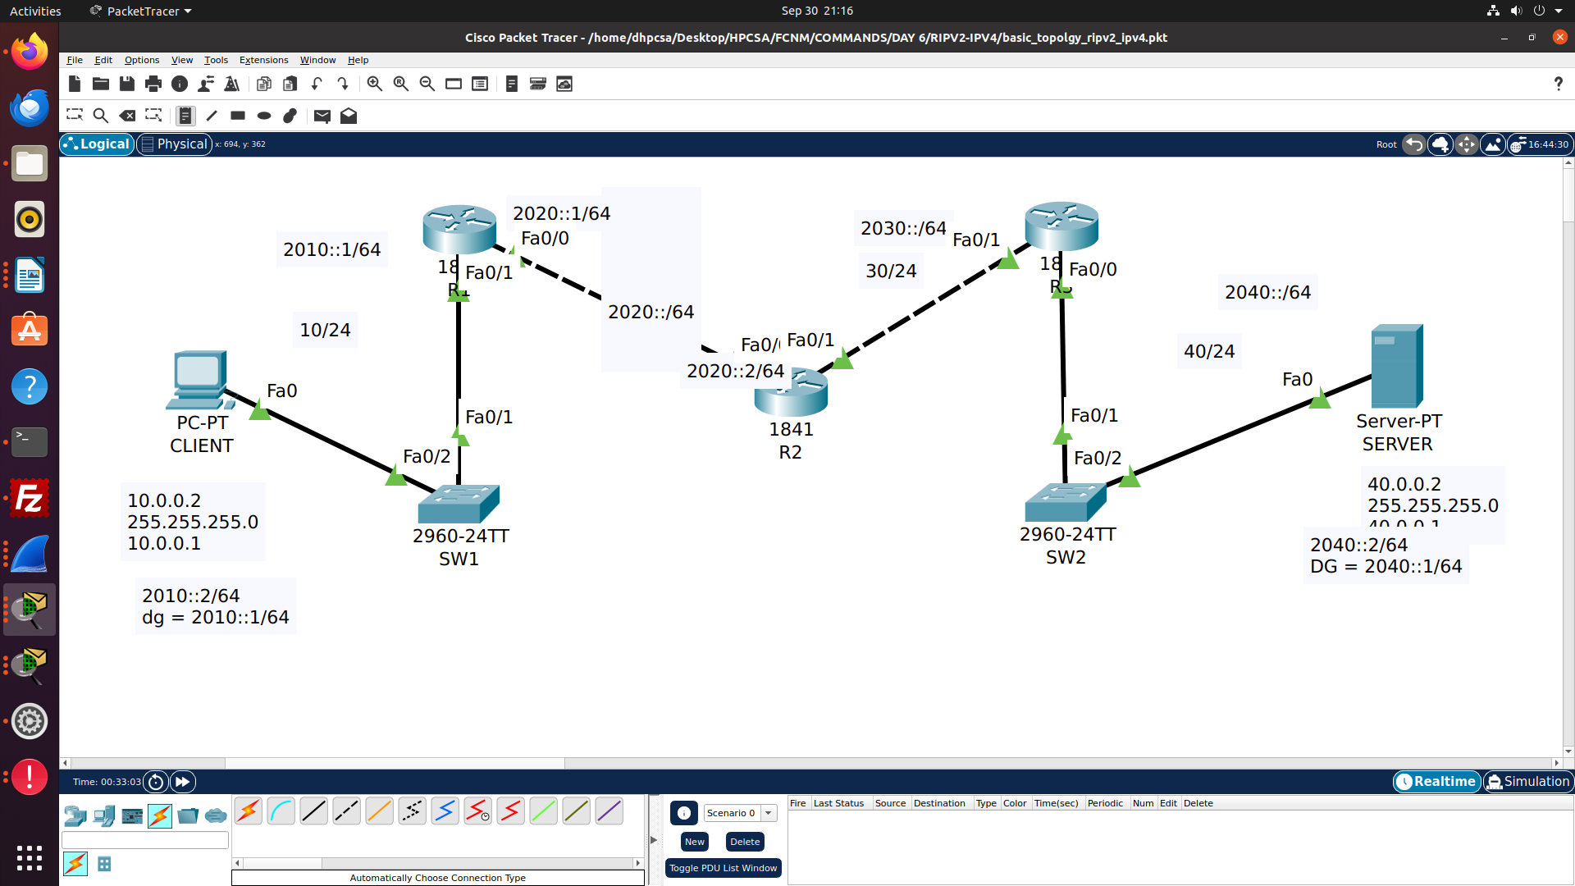

pc
C:\>ipconfig

FastEthernet0 Connection:(default port)

Connection-specific DNS Suffix..:
Link-local IPv6 Address.........: FE80::2E0:8FFF:FE10:B16A
IPv6 Address....................: 2010::2
IPv4 Address....................: 10.0.0.2
Subnet Mask.....................: 255.255.255.0
Default Gateway.................: 2010::1
10.0.0.1

Bluetooth Connection:

Connection-specific DNS Suffix..:
Link-local IPv6 Address.........: ::
IPv6 Address....................: ::
IPv4 Address....................: 0.0.0.0
Subnet Mask.....................: 0.0.0.0
Default Gateway.................: ::
0.0.0.0

check ipv4 connectivty (after configuring ripv2 on ipv4)
C:\>ping 40.0.0.2

Pinging 40.0.0.2 with 32 bytes of data:

Request timed out.
Reply from 40.0.0.2: bytes=32 time<1ms TTL=125
Reply from 40.0.0.2: bytes=32 time<1ms TTL=125
Reply from 40.0.0.2: bytes=32 time<1ms TTL=125

Ping statistics for 40.0.0.2:
Packets: Sent = 4, Received = 3, Lost = 1 (25% loss),
Approximate round trip times in milli-seconds:
Minimum = 0ms, Maximum = 0ms, Average = 0ms

R1(config)#ipv6 unicast-routing
R1(config)#int fastEthernet 0/1
R1(config-if)#ipv6 address 2010::1/64
R1(config-if)#no shutdown

R1(config)#int fastEthernet 0/0
R1(config-if)#ipv6 address 2020::1/64
R1(config-if)#no shutdown

R2(config)#ipv6 unicast-routing
R2(config)#int fastEthernet 0/0
R2(config-if)#ipv6 address 2020::2/64
R2(config-if)#no shutdown

R2(config)#int fastEthernet 0/1
R2(config-if)#ipv6 address 2030::1/64
R2(config-if)#no shutdown

R3(config)#ipv6 unicast-routing
R3(config)#int fastEthernet 0/1
R3(config-if)#ipv6 address 2030::2/64
R3(config-if)#no shutdown

R3(config)#int fastEthernet 0/1
R3(config-if)#ipv6 address 2040::1/64
R3(config-if)#no shutdown

Static Routing IPV6 Commands on Router R1
R1(config)#ipv6 route 2030::/64 2020::2
R1(config)#ipv6 route 2040::/64 2020::2

R2(config)#ipv6 route 2010::/64 2020::1
R2(config)#ipv6 route 2040::/64 2030::2

R3(config)#ipv6 route 2010::/64 2030::1
R3(config)#ipv6 route 2020::/64 2030::1

R1#sh ipv6 route
IPv6 Routing Table - 7 entries
Codes: C - Connected, L - Local, S - Static, R - RIP, B - BGP
U - Per-user Static route, M - MIPv6
I1 - ISIS L1, I2 - ISIS L2, IA - ISIS interarea, IS - ISIS summary
ND - ND Default, NDp - ND Prefix, DCE - Destination, NDr - Redirect
O - OSPF intra, OI - OSPF inter, OE1 - OSPF ext 1, OE2 - OSPF ext 2
ON1 - OSPF NSSA ext 1, ON2 - OSPF NSSA ext 2
D - EIGRP, EX - EIGRP external
C 2010::/64 [0/0]
via ::, FastEthernet0/1
L 2010::1/128 [0/0]
via ::, FastEthernet0/1
C 2020::/64 [0/0]
via ::, FastEthernet0/0
L 2020::1/128 [0/0]
via ::, FastEthernet0/0
S 2030::/64 [1/0]
via 2020::2
S 2040::/64 [1/0]
via 2020::2
L FF00::/8 [0/0]
via ::, Null0

To remove static routing ipv6 from routers

R1(config)#no ipv6 route 2030::/64 2020::2
R1(config)#no ipv6 route 2040::/64 2020::2

R2(config)#no ipv6 route 2010::/64 2020::1
R2(config)#no ipv6 route 2040::/64 2030::2

R2(config)#no ipv6 route 2010::/64 2030::1
R2(config)#no ipv6 route 2020::/64 2030::1

Dynamic routing protocol RIPV6

R1(config)#ipv6 router rip cdac
R1(config-rtr)#exit
R1(config)#int fastEthernet 0/1
R1(config-if)#ipv6 rip cdac enable
R1(config)#int fastEthernet 0/0
R1(config-if)#ipv6 rip cdac enable

R2(config)#ipv6 router rip cdac
R2(config-rtr)#exit
R2(config)#int fastEthernet 0/1
R2(config-if)#ipv6 rip cdac enable
R2(config)#int fastEthernet 0/0
R2(config-if)#ipv6 rip cdac enable

R3(config)#ipv6 router rip cdac
R3(config-rtr)#exit
R3(config)#int fastEthernet 0/1
R3(config-if)#ipv6 rip cdac enable
R3(config)#int fastEthernet 0/0
R3(config-if)#ipv6 rip cdac enable

C:\>ping 2040::2

Pinging 2040::2 with 32 bytes of data:

Reply from 2040::2: bytes=32 time<1ms TTL=125
Reply from 2040::2: bytes=32 time<1ms TTL=125
Reply from 2040::2: bytes=32 time<1ms TTL=125
Reply from 2040::2: bytes=32 time<1ms TTL=125

Ping statistics for 2040::2:
Packets: Sent = 4, Received = 4, Lost = 0 (0% loss),
Approximate round trip times in milli-seconds:
Minimum = 0ms, Maximum = 0ms, Average = 0ms

R1#sh ipv6 interface brief
FastEthernet0/0 [up/up]
FE80::201:97FF:FECA:DA01
2020::1
FastEthernet0/1 [up/up]
FE80::201:97FF:FECA:DA02
2010::1
Vlan1 [administratively down/down]
unassigned

R1#sh ipv6 route
IPv6 Routing Table - 7 entries
Codes: C - Connected, L - Local, S - Static, R - RIP, B - BGP
U - Per-user Static route, M - MIPv6
I1 - ISIS L1, I2 - ISIS L2, IA - ISIS interarea, IS - ISIS summary
ND - ND Default, NDp - ND Prefix, DCE - Destination, NDr - Redirect
O - OSPF intra, OI - OSPF inter, OE1 - OSPF ext 1, OE2 - OSPF ext 2
ON1 - OSPF NSSA ext 1, ON2 - OSPF NSSA ext 2
D - EIGRP, EX - EIGRP external
C 2010::/64 [0/0]
via ::, FastEthernet0/1
L 2010::1/128 [0/0]
via ::, FastEthernet0/1
C 2020::/64 [0/0]
via ::, FastEthernet0/0
L 2020::1/128 [0/0]
via ::, FastEthernet0/0
R 2030::/64 [120/2]
via FE80::201:C7FF:FE94:4E01, FastEthernet0/0
R 2040::/64 [120/3]
via FE80::201:C7FF:FE94:4E01, FastEthernet0/0
L FF00::/8 [0/0]
via ::, Null0

